Web Scrapping and Geographical Heat Map of Cities and their GDP

# Problem & background

We are trying to find the top 50 cities and plot a heat map of these cities according to their GDP size

# Solution

Use of web scrapping and bing map add-in is used

# Methodology & Project scope

1. Data is collected from website (I selected Wikipedia)
2. Then data is cleaned
3. Heat map is plotted using Bing add-in

# Goals & KPIs

1. Obtain Data
2. Plot in a map

# Concepts Used

1. Web Scrapping->Data Tab->Get Data from Web->Transform and Load Data
2. Bing Map add-in->Insert map->Select the data field

# Conclusion

|  |  |
| --- | --- |
| Metropolitan area | Visual Capitalist[5] 2021 est. GDP (million US$) |
| Tokyo | 2055698 |
| New York | 1874398 |
| Los Angeles | 1133627 |
| Seoul | 926790 |
| Paris | 934168 |
| London | 978402 |
| Shanghai | 661600 |
| Moscow | 504808 |
| Beijing | 591374 |
| Osaka–Kobe | 699474 |
| Istanbul | 247312 |
| Jakarta | 308250 |
| Chicago | 714697 |
| Shenzhen | 455694 |
| Rhine-Ruhr | 636449 |
| Guangzhou | 405355 |
| Chongqing | 407562 |
| Mumbai | 277980 |
| Singapore | 374394 |
| Delhi | 272603 |
| San Francisco | 593629 |
| Taipei | 407838 |
| São Paulo | 261642 |
| Washington, D.C. | 578985 |
| Bangkok | 252128 |
| Mexico City | 250455 |
| Suzhou | 356800 |
| Dallas–Fort Worth | 523854 |
| Boston | 513211 |
| Houston | 489377 |
| Chengdu | 260409 |
| Toronto | 452492 |
| Hong Kong | 368633 |
| Philadelphia | 455653 |
| Seattle | 444337 |
| Atlanta | 432009 |
| Wuhan | 282500 |
| Milan | 329529 |
| Nagoya | 379301 |
| Hangzhou | 248721 |
| Miami | 388725 |
| Madrid | 280937 |
| Tianjin | 237900 |
| Nanjing | 249800 |
| Sydney | 398037 |
| Melbourne | 318677 |
| San Diego | 290330 |
| Phoenix | 341841 |
| Minneapolis-St. Paul | 342373 |
| Detroit | 357731 |
| Busan–Gyeongnam Area | 252145 |
| Munich | 249764 |
| Berlin | 243160 |

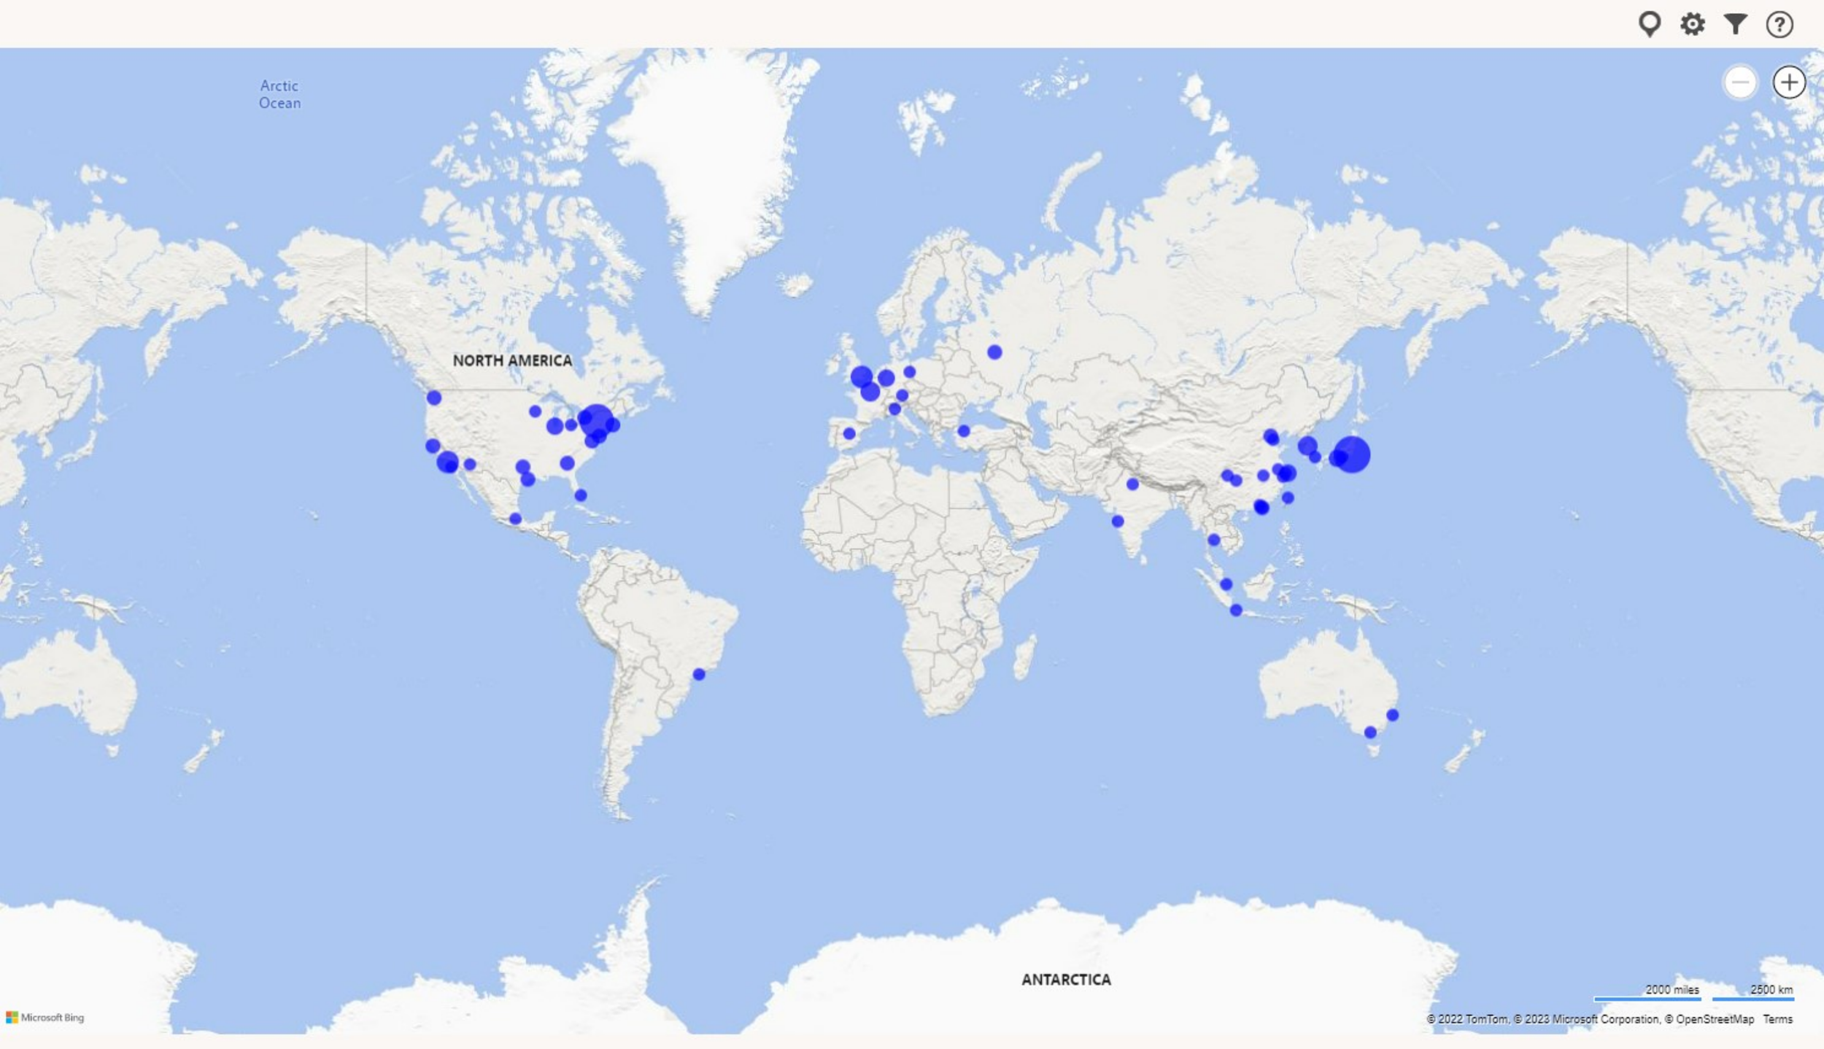

# Project owner

Name: Shreshth Vashisht

Date: February 26th 2023